STEP:1

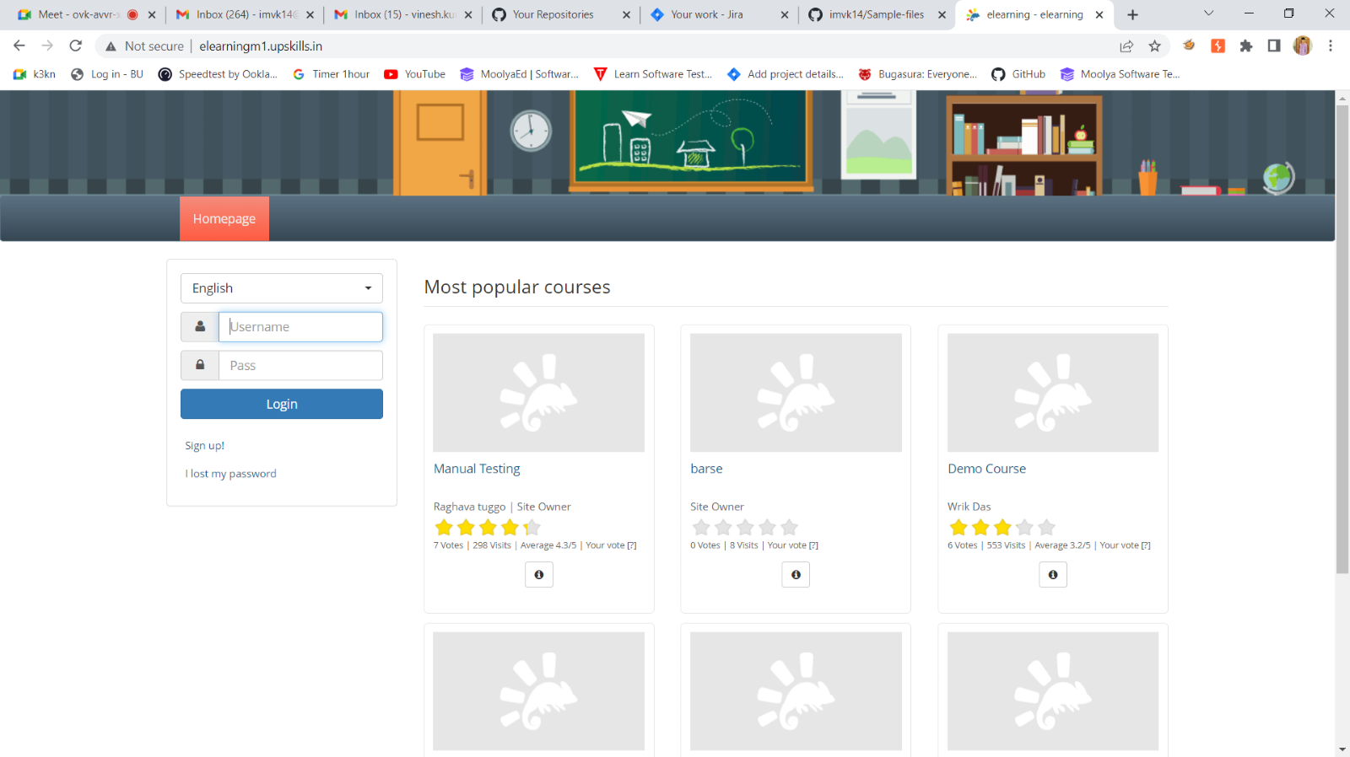

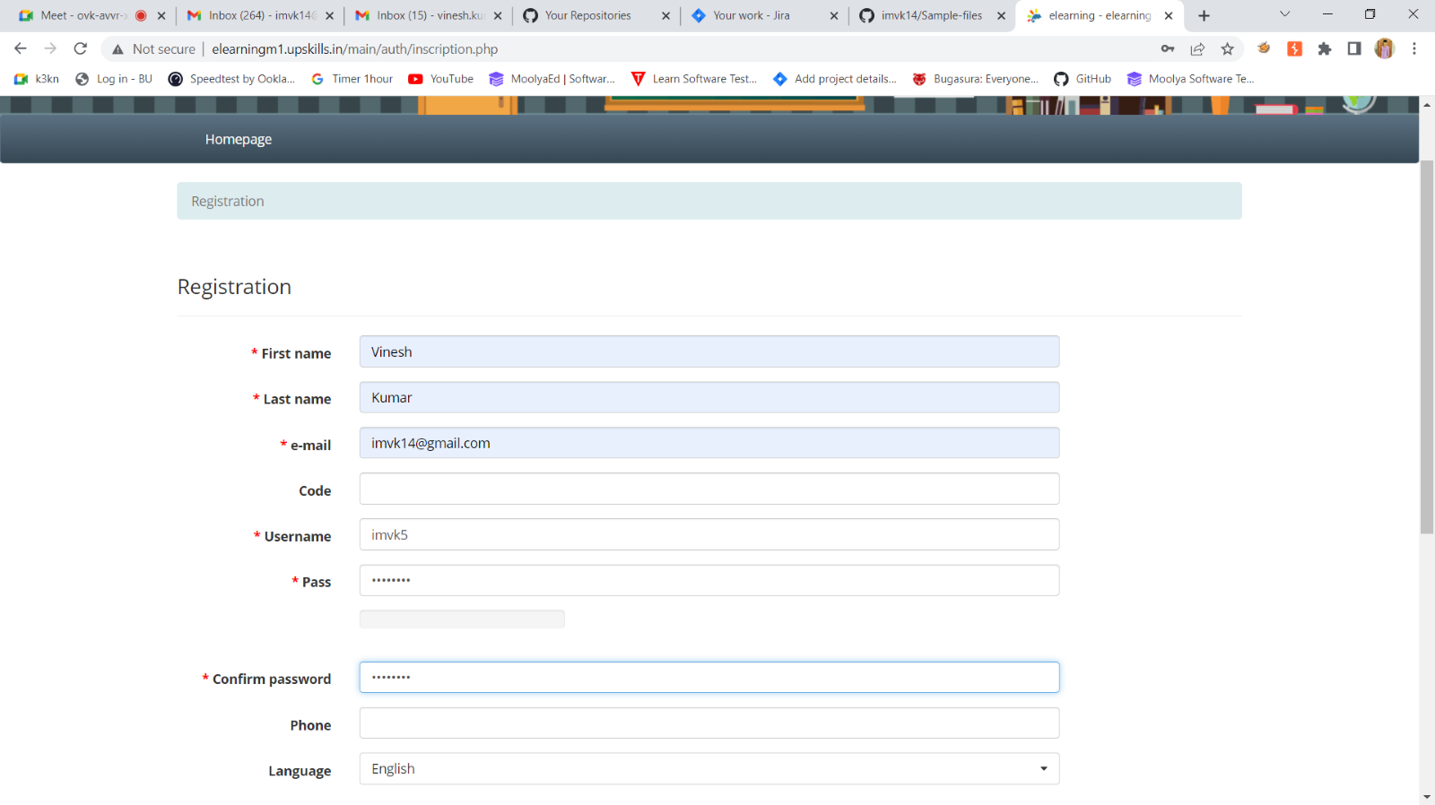

STEP:2 LOG IN PAGE

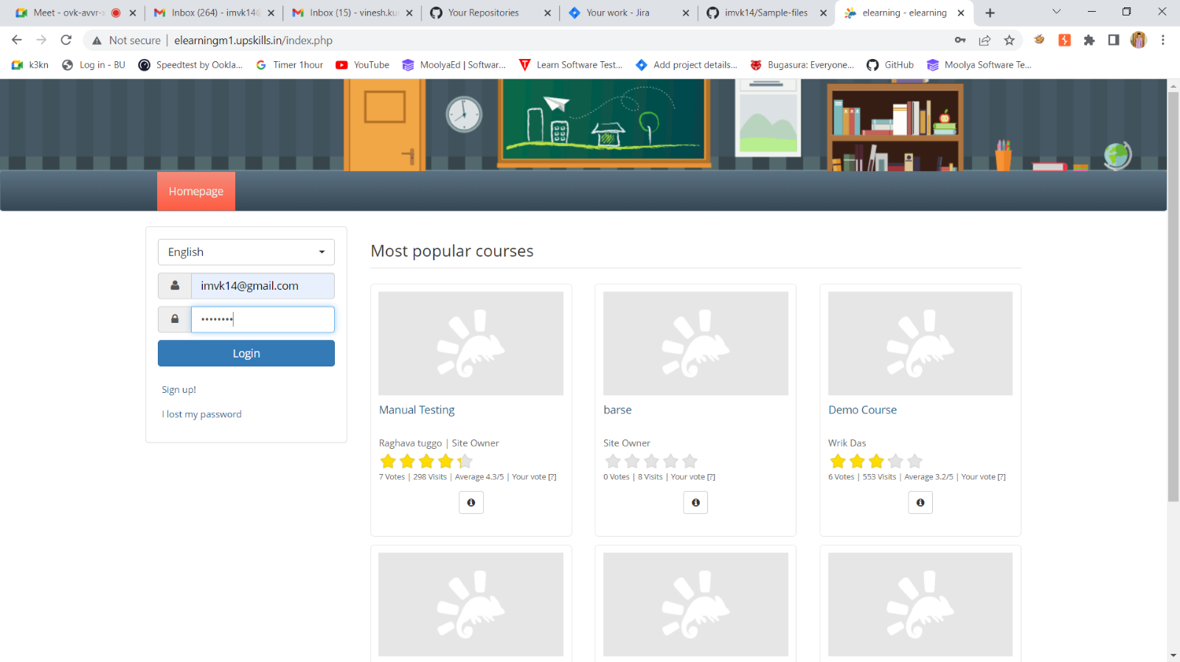

STEP:3 LOG IN CONFIRMATION MESSAGE

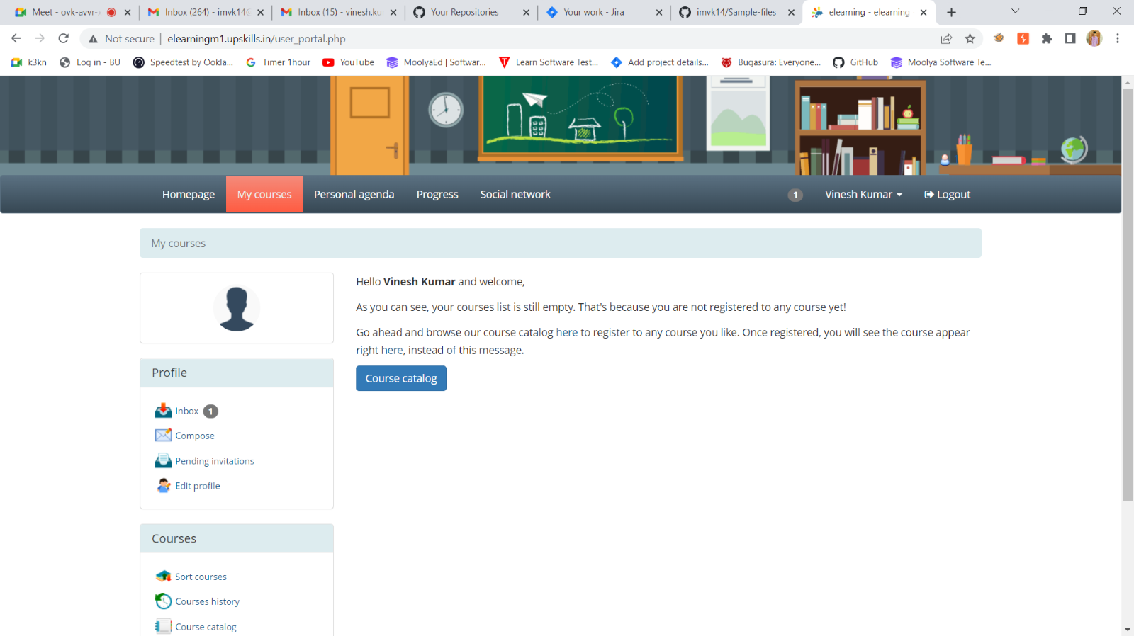

STEP:4 DISPLAY MY COURSES PAGE

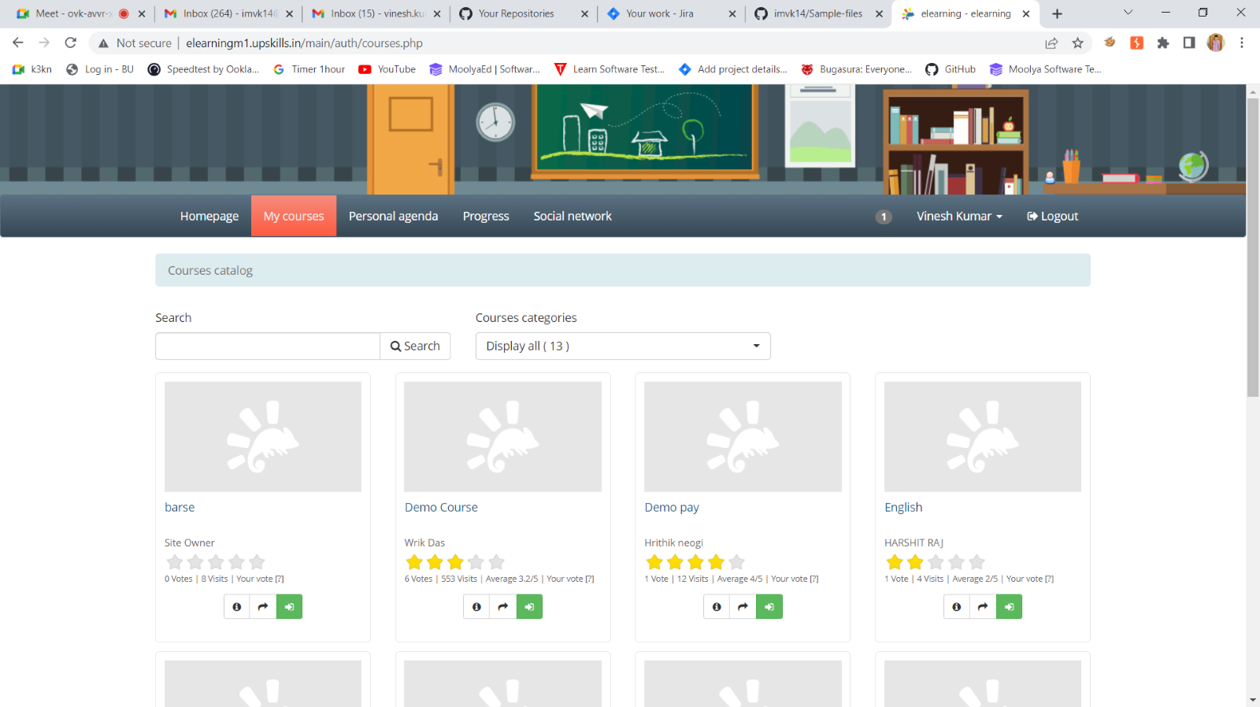

STEP:5 DISPLAY THE PROFILE PAGE

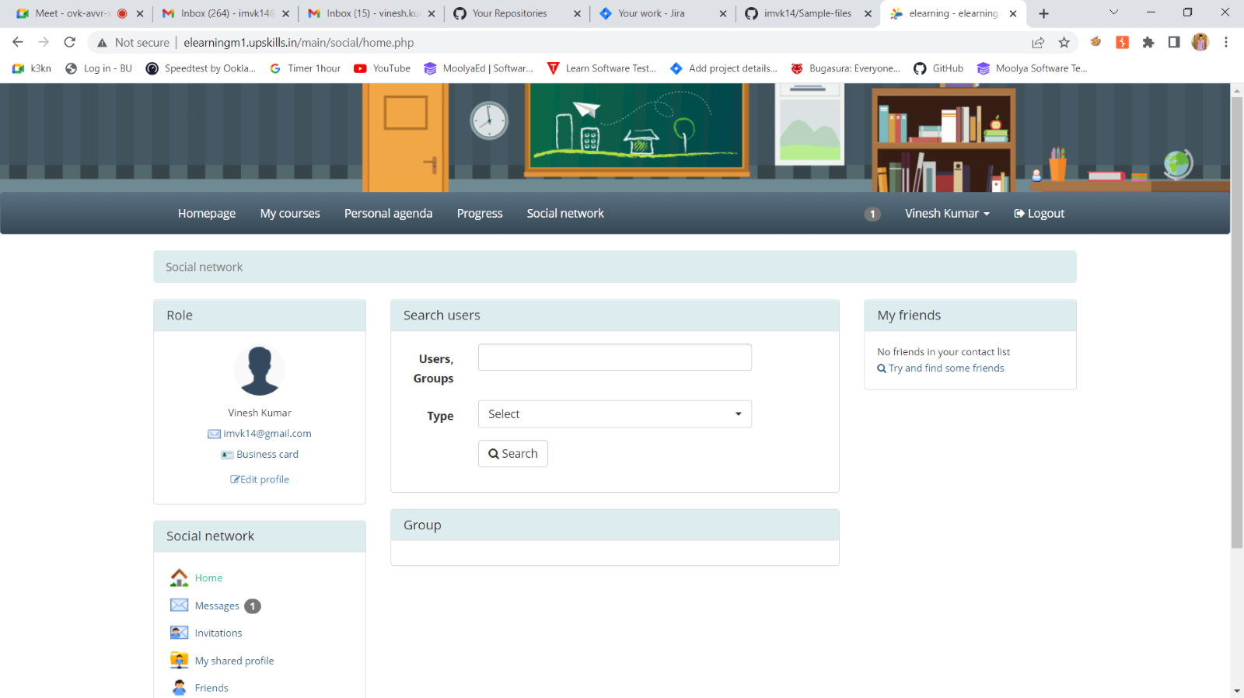

STEP:6 DISPLAY COMPOSE MESSAGE

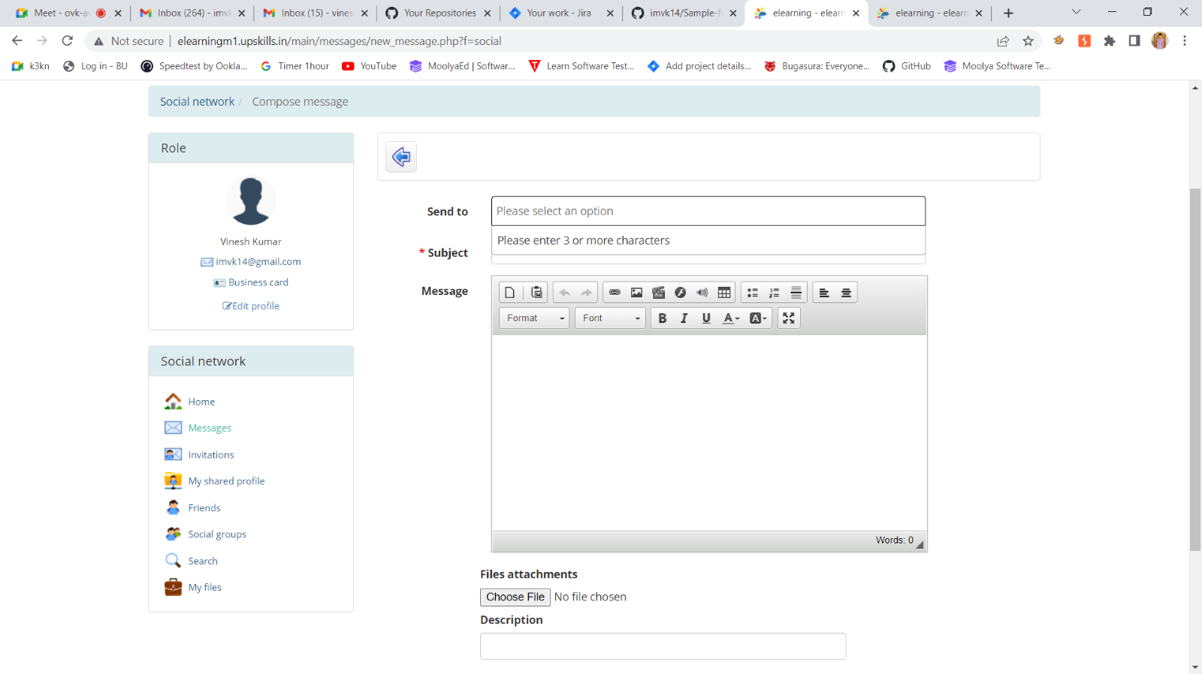

STEP:7 SEND MESSAGE PAGE

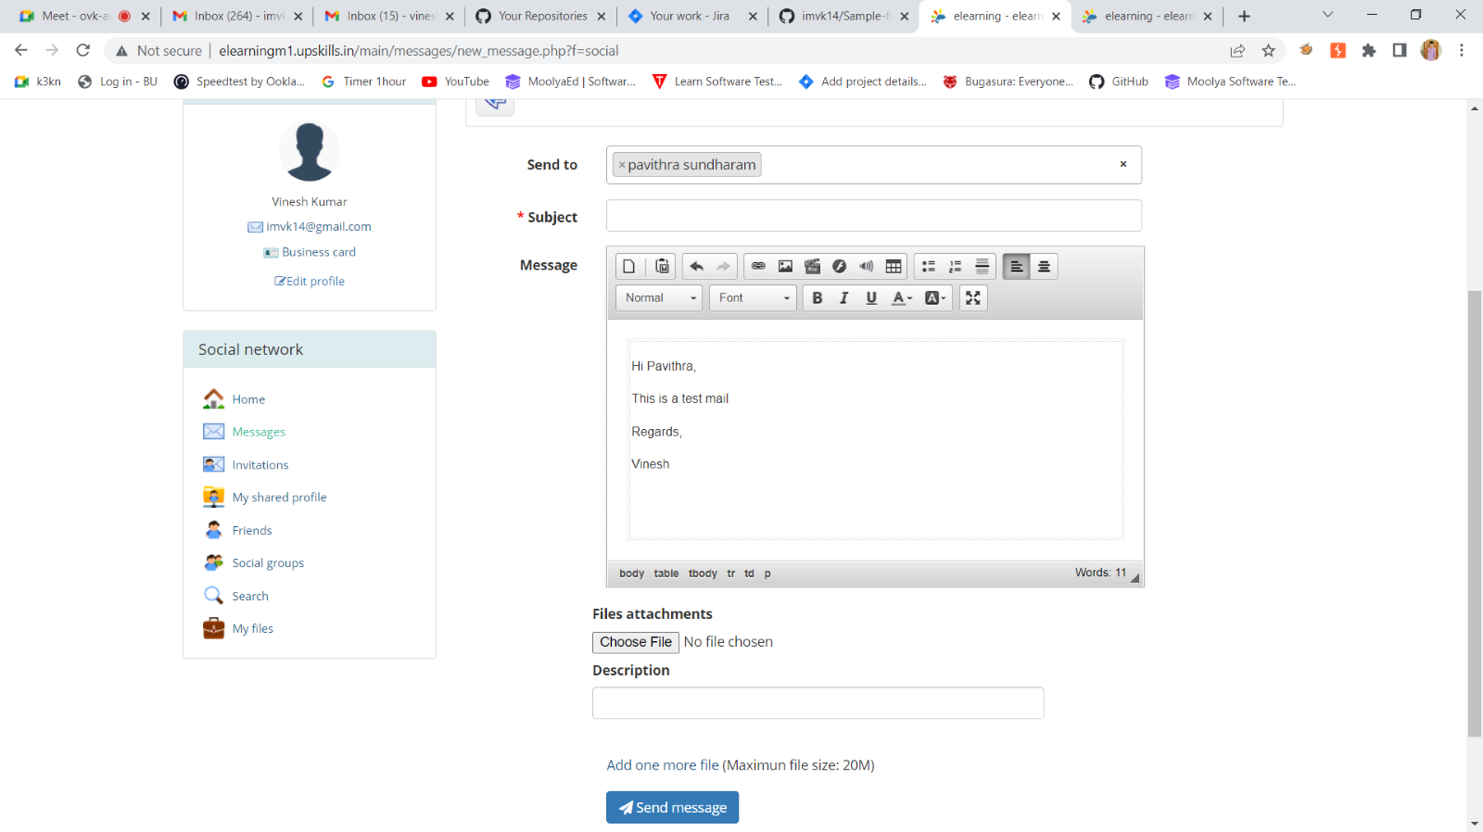

STEP:8 CONFIRMATION MESSAGE

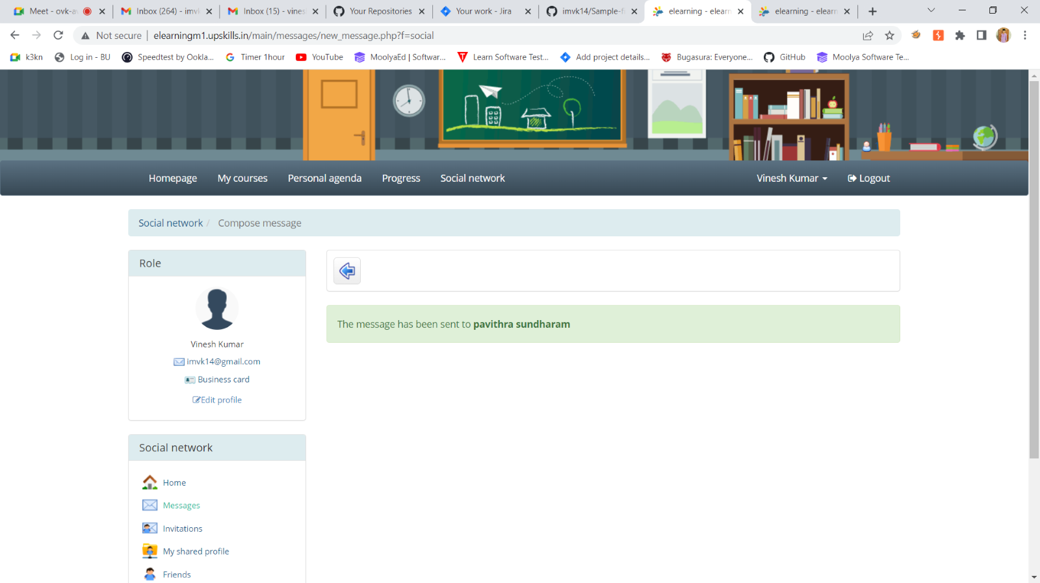

STEP:9 ADDING EPIC & USER STORIES

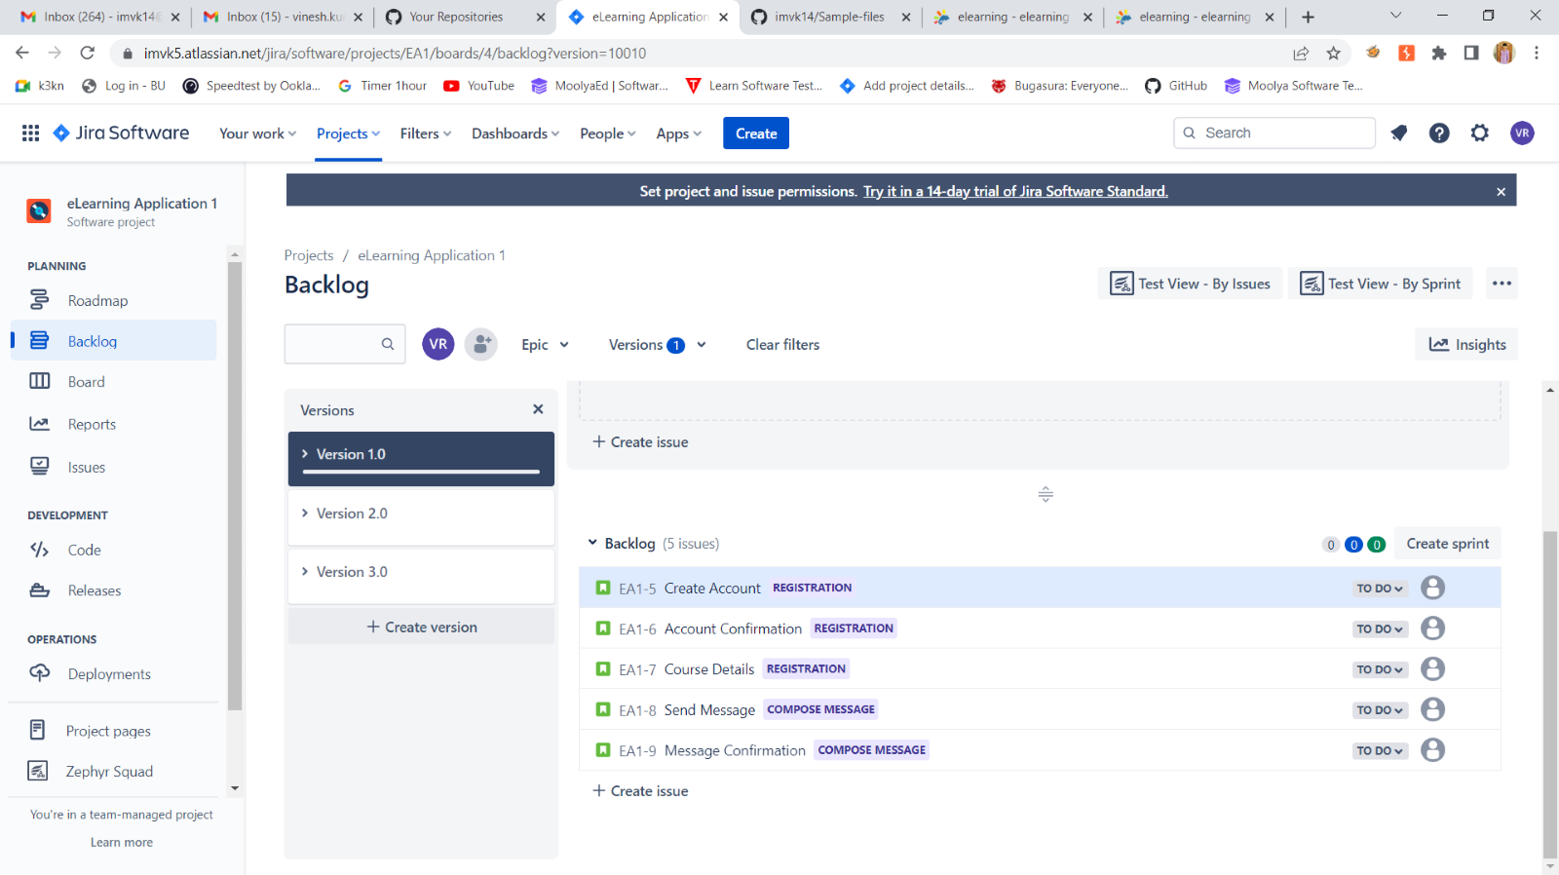

STEP:10 CREATE A NEW ISSUE TYPE :TEST

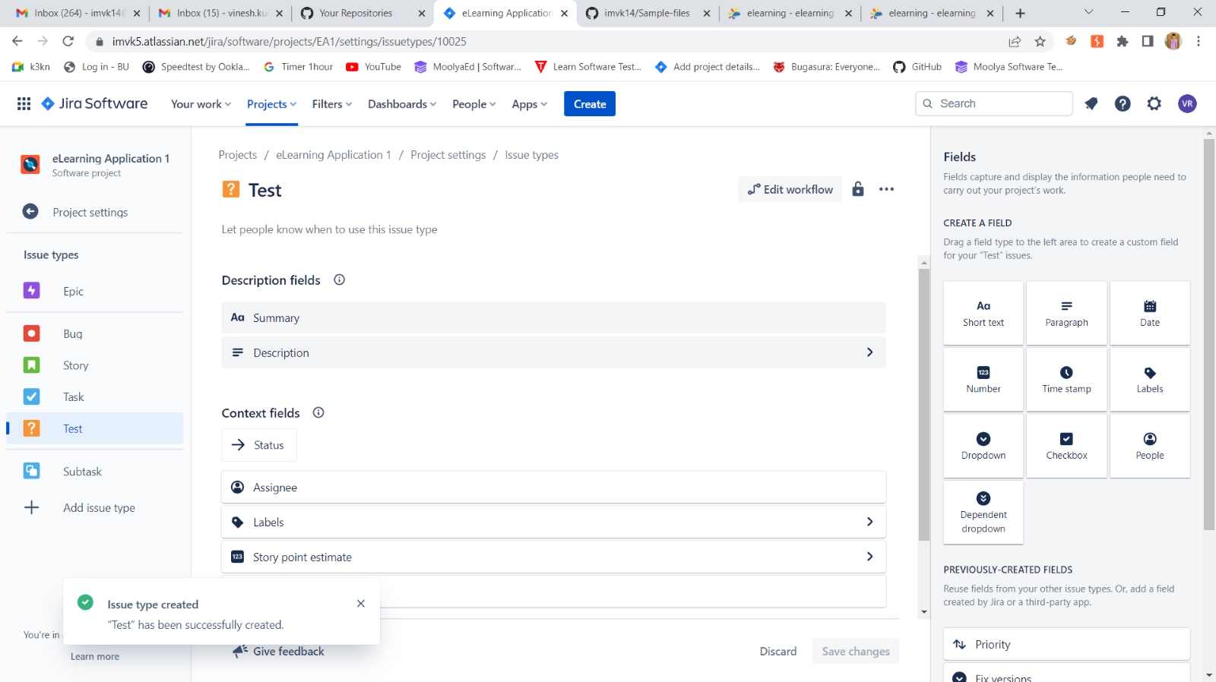

STEP:11 ADD THE ISSUE TYPE IN ZEPHYR SQUAD

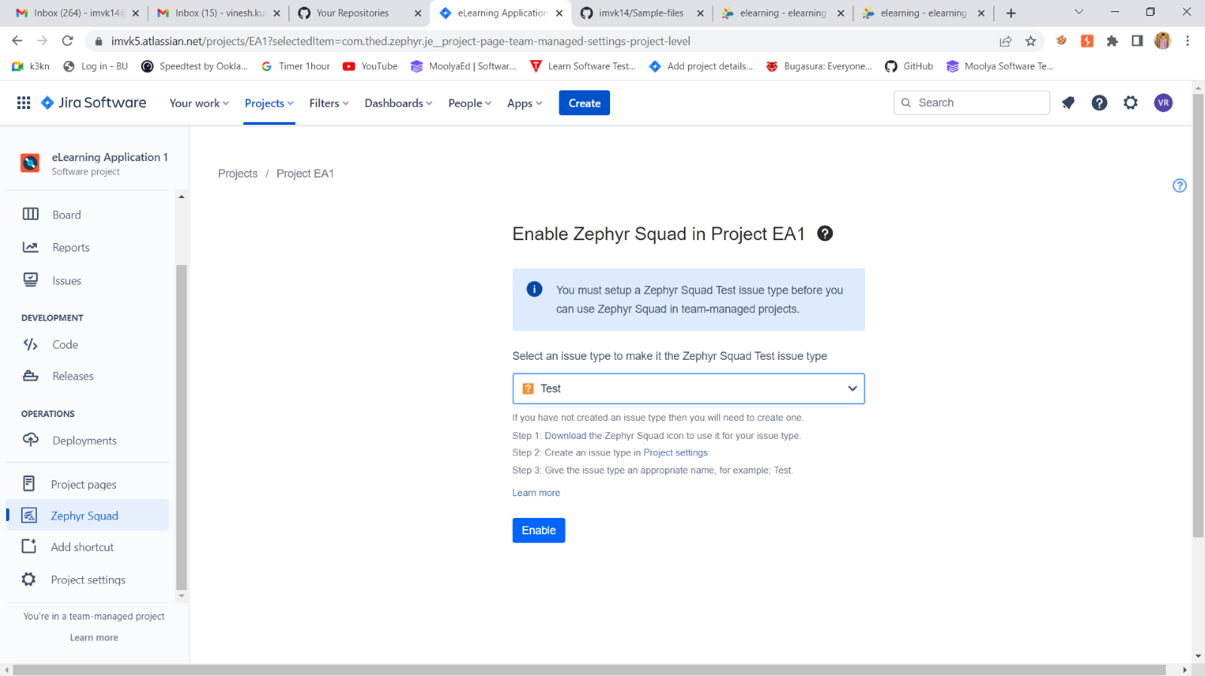

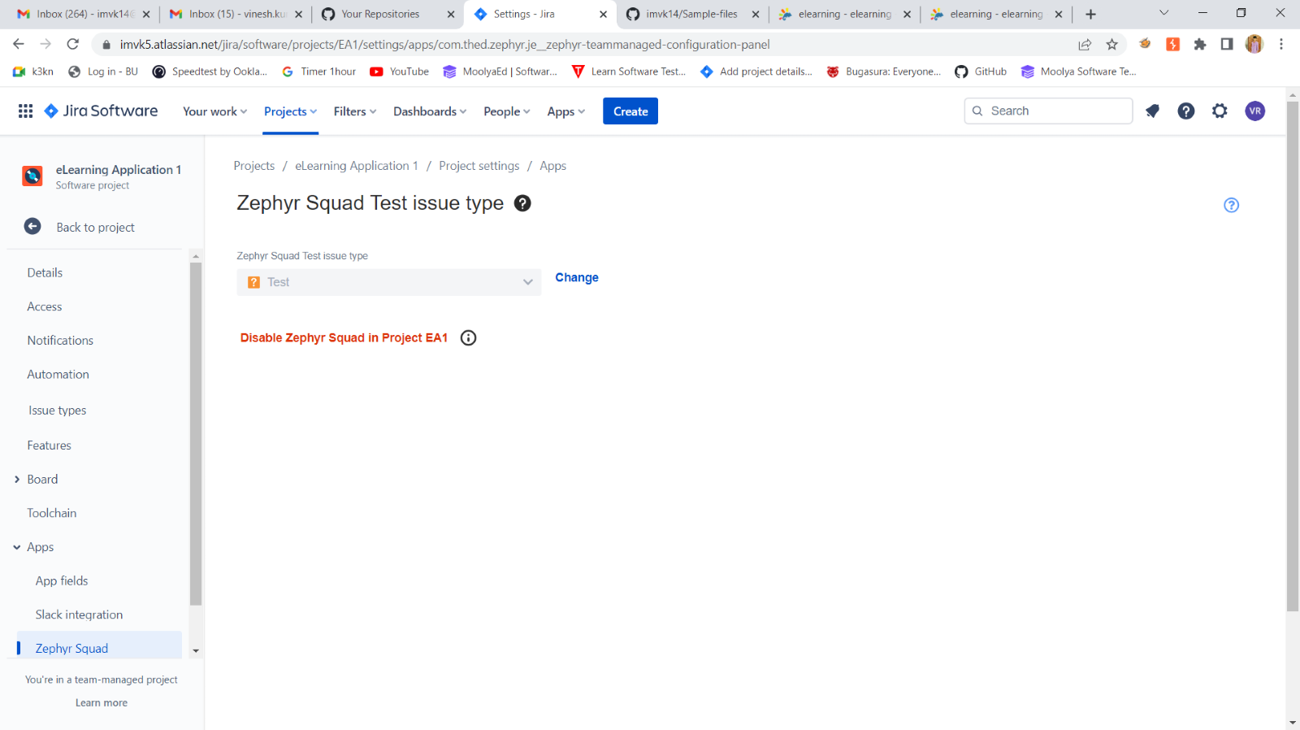

STEP:12 ADD ALL TO THE SPRINT1

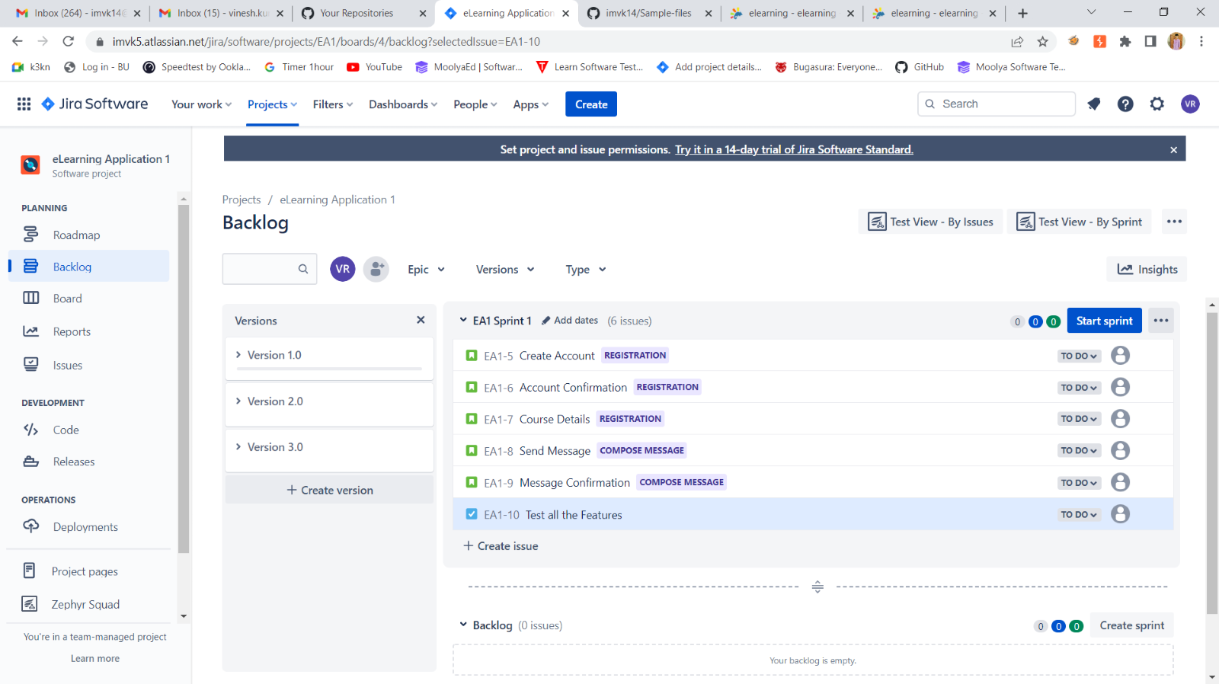

STEP:13 CREATING THE TEST CASE IN ZEPHYR SQUAD

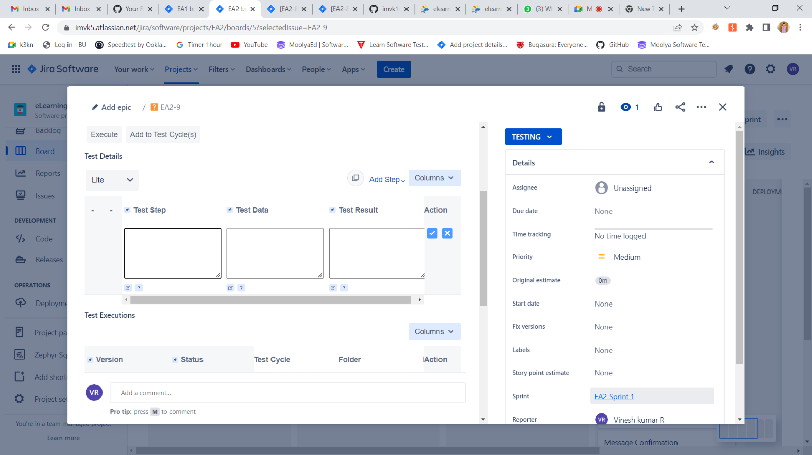

STEP:14 ADD ALL THE TEST CASE IN TO ZEPHYR SQUAD

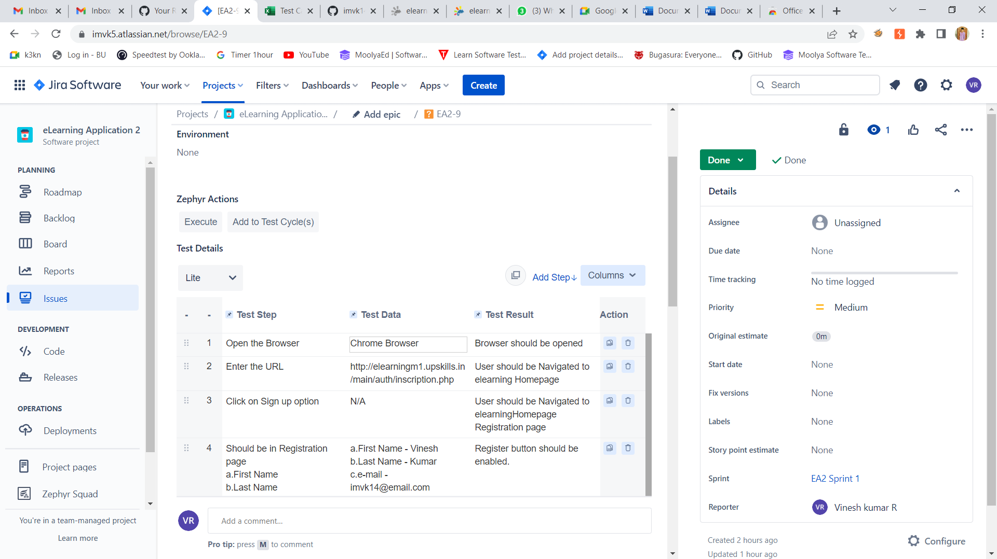

STEP:15 AFTER EXECUTION RESULT IS PASS

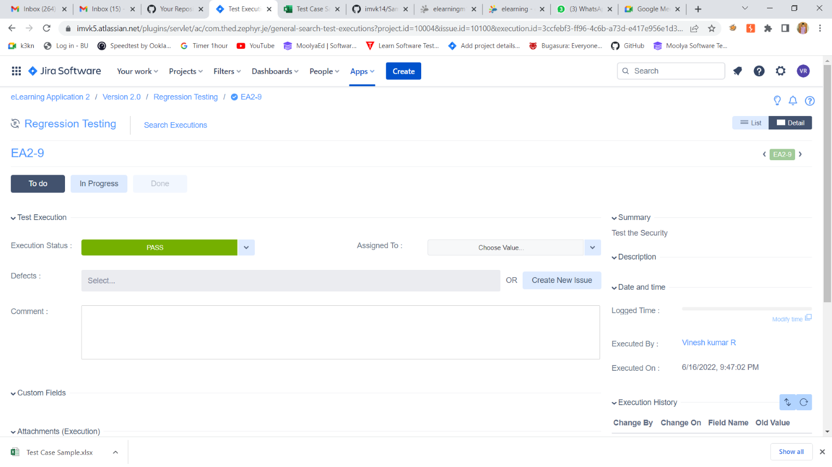

STEP:16 AFTER EXECUTION I RELEASE THE PRODUCT

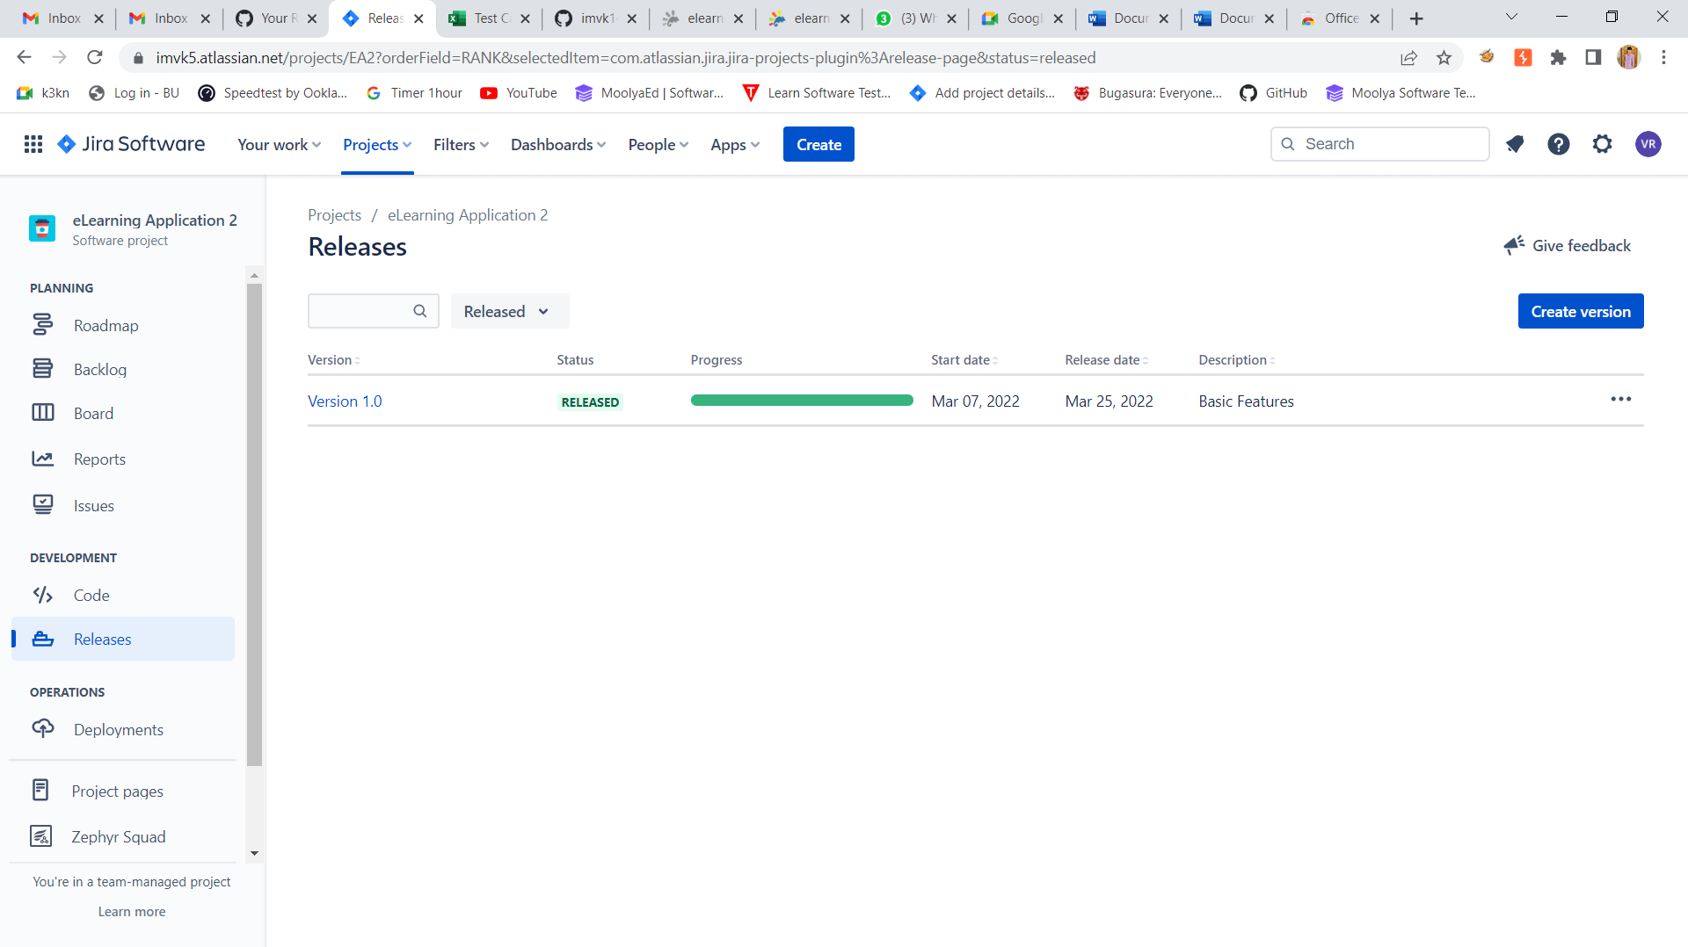

STEP:17 TEST METRICS REPORT

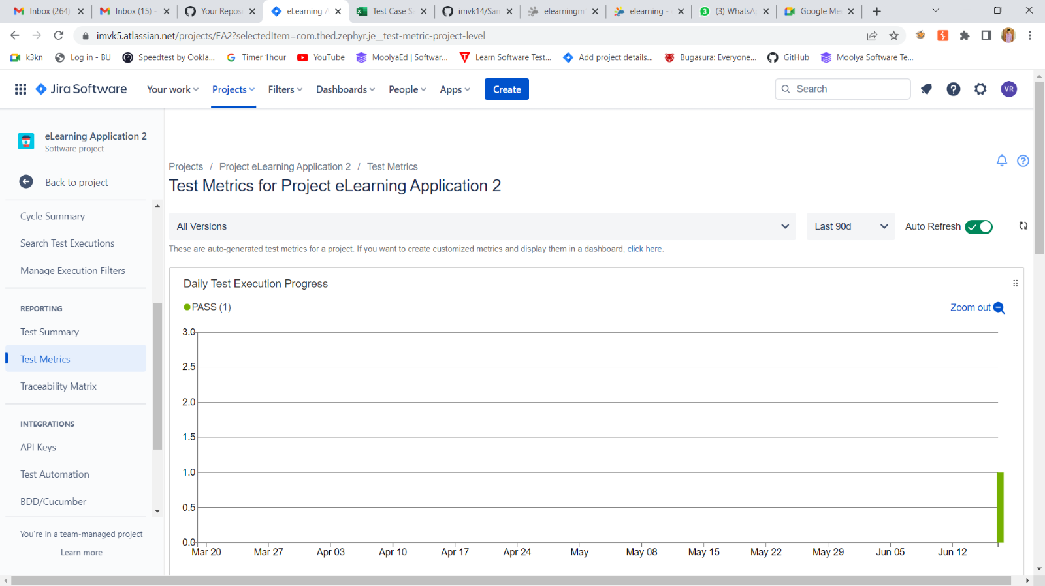

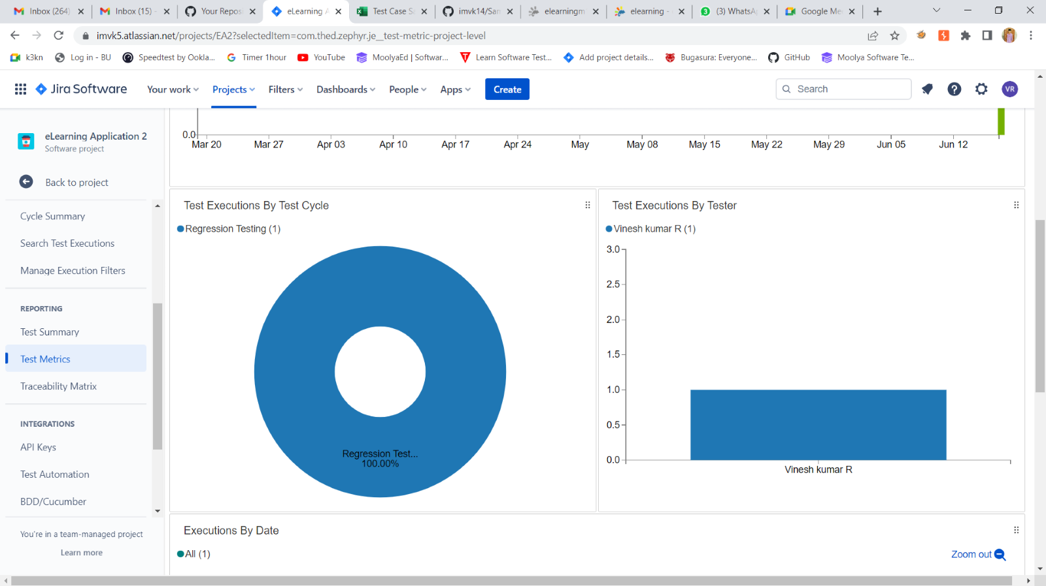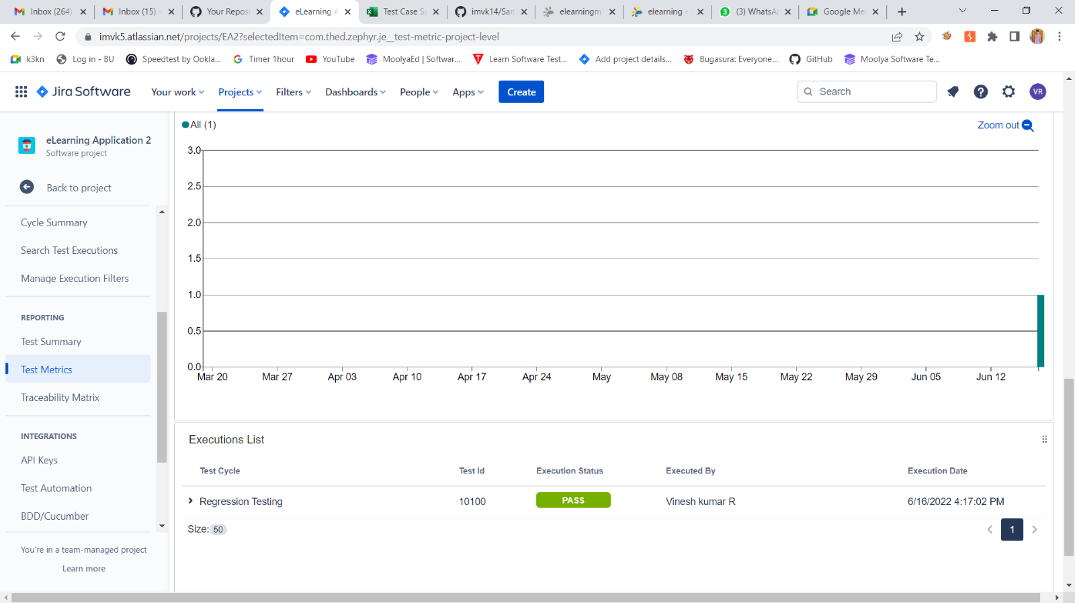

STEP:18 TRACEABILITY MATRIX

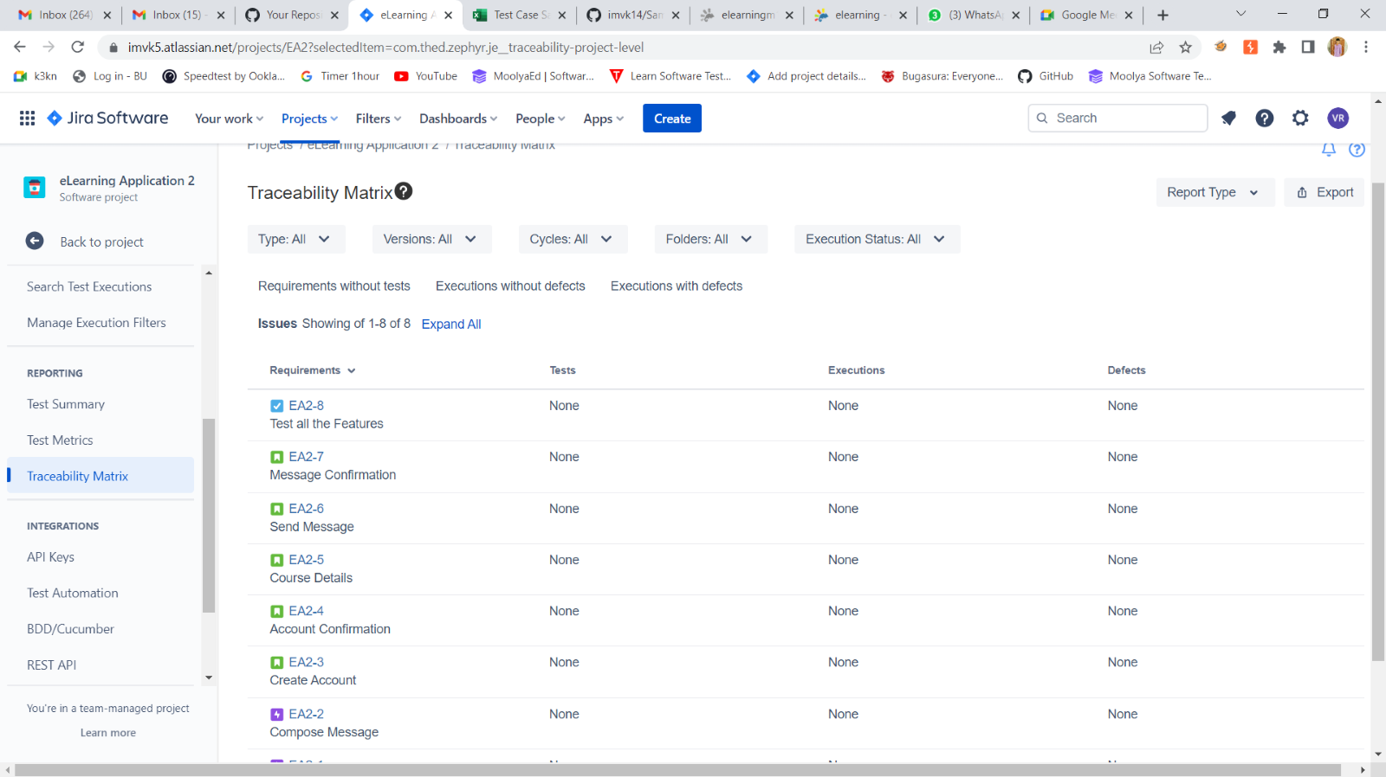

STEP:19 TEST SUMMARY

